DESIGN AND IMPLEMENTATION OF SEGMENTED VLAN NETWORK USING ROAS (ROUTER ON A STICK)
I am Kaitochukwu onwuesi-nwigwe and this is a documentation of a project I did on the 14th of May, 2026.

OVERVIEW
This is a packet tracer designed network, consisting of four VLAN each with two PCs, two switches, and one router.

PURPOSE OF PROJECT
The purpose of this project was to solidify my knowledge on these already learnt concepts, by building my own network from scratch, doing all the configurations, simulating it to monitor how packets and frames move on such networks, debunk misconceptions I had about certain concepts, and put myself in a situation where I have to troubleshoot.

DESIGN TOPOLOGY
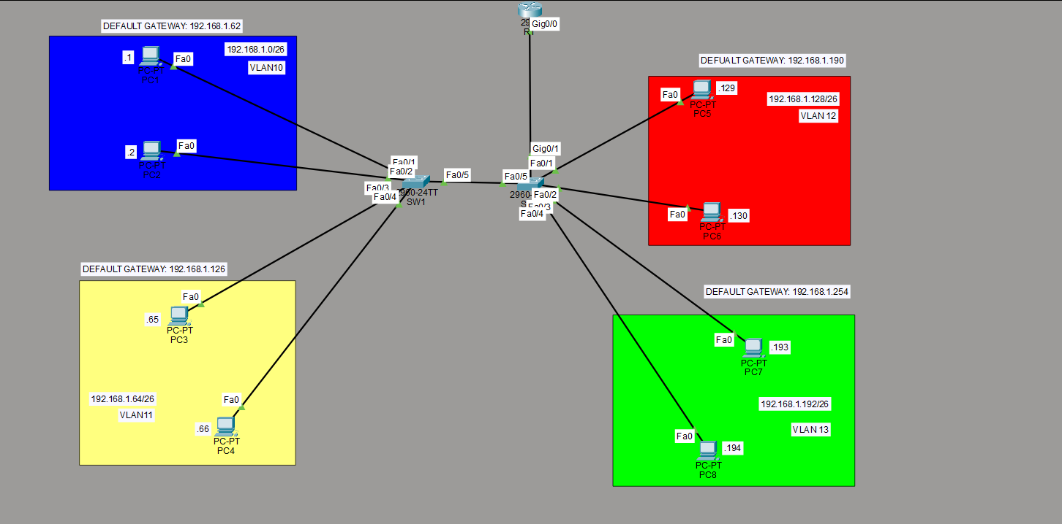
Figure 1: Network Topology

VLAN TABLE
Below is the table of each VLAN, showing their network address, subnet mask and default gateway.
VLAN | NETWORK ADDRESS | DEFAULT GATEWAY | SUBNET MASK
10 | 192.168.1.0/26 | 192.168.1.62 | 255.255.255.192
11 | 192.168.1.64/26 | 192.168.1.126 | 255.255.255.192
12 | 192.168.1.128/26 | 192.168.1.190 | 255.255.255.192
13 | 192.168.1.192/26 | 192.168.1.254 | 255.255.255.192

CONFIGURATIONS
The entire configuration for this project was done like this:

VLAN 10
PC1
IP address: 192.168.1.1
Default gateway: 192.168.1.62
Subnet mask: 255.255.255.192
PC2
IP address: 192.168.1.2
Default Gateway: 192.168.1.62
Subnet mask: 255.255.255.192

VLAN 11
PC3
IP address: 192.168.1.65
Default Gateway: 192.168.1.126
Subnet mask: 255.255.255.192

PC4
IP address: 192.168.1.66
Default Gateway: 192.168.1.126
Subnet mask: 255.255.255.192

VLAN 12
PC5
IP address: 192.168.1.129
Default Gateway: 192.168.1.190
Subnet mask: 255.255.255.192
PC6
IP address: 192.168.1.130
Default Gateway: 192.168.1.190
Subnet mask: 255.255.255.192

VLAN 13
PC7
IP address: 192.168.1.193
Default Gateway: 192.168.1.254
Subnet mask: 255.255.255.192
PC8
IP address: 192.168.1.194
Default Gateway: 192.168.1.254
Subnet mask: 255.255.255.192

SWITCHES

SW1

F0/1 and F0/2
They were configured as access ports for VLAN 10 using the appropriate commands: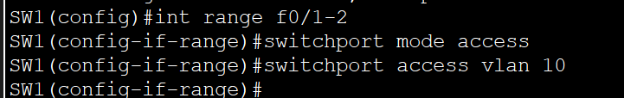
Figure 2: Switch 1's F0/1 and F0/2 interface config
F0/3 and F0/4
They were configured as access ports for VLAN 11 using the appropriate commands:
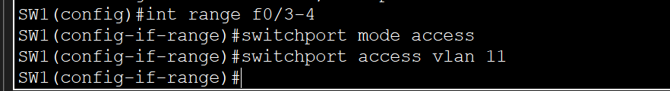
Figure 3: Switch 1's F0/3 and F0/4 interfaces config

F0/5
This was configured as a trunk port that allowed VLAN 10 and VLAN 11 to go through, with the appropriate commands:
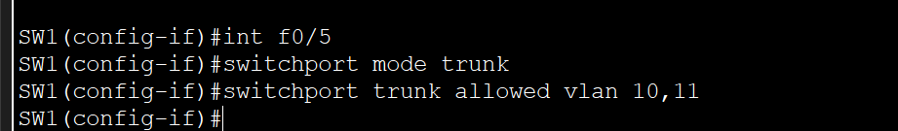
Figure 4: Switch 1's F0/5 interface config

Native VLAN
We set the native VLAN to an unused VLAN using the appropriate command:
Figure 5: Native VLAN configuration for switch 1

SW2

F0/1 and F0/2
They were configured as access ports for VLAN 12 using the appropriate commands:
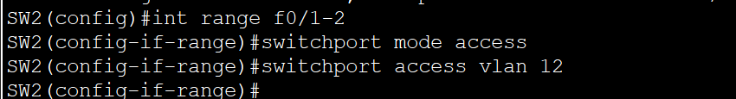
Figure 6: Switch 2's F0/1 and F0/2 interface config
F0/3 and F0/4
They were configured as access ports for VLAN 13 using the appropriate commands:
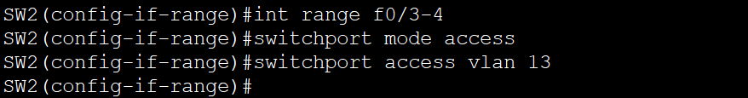
Figure 7: Switch 2's F0/3 and F0/4 interface config

F0/5
This was configured as a trunk port that allowed VLAN 10 and VLAN 11 to go through, with the appropriate commands:
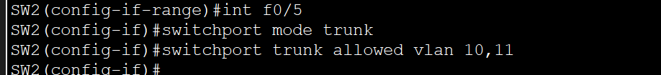
Figure 8: Switch 2's F0/5 interface config

Native VLAN
We set the native VLAN to an unused VLAN using the appropriate command:
Figure 9: Native VLAN configuration for Switch 2

G0/1
This was configured as a trunk port that allowed all the VLANs to go through with the appropriate commands:
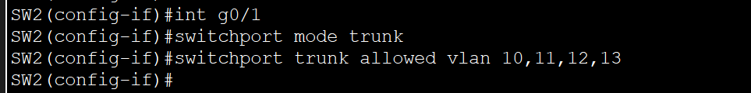
Figure 10: Switch 2's G0/1 interface config

ROUTER

R1

G0/0:
I enabled this interface, then created four sub-interfaces, for the four VLANs then I, ensured each sub-interface will get their IEEE 802.1Q tag and IP address for the specific VLAN traffic using the appropriate commands: 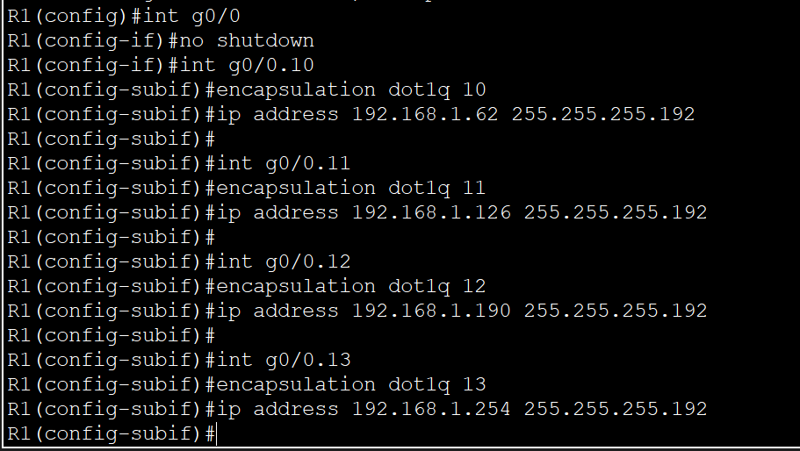
Figure 11: The router's G0/0 interface "On a stick" configurations

CONFIGURATION RATIONALE
Why did I do my configurations like this. This is what this section will be explaining.

PC CONFIG RATIONALE
I sub-netted the 192.168.1.0/24 network into 4 subnets of 62 usable host each. This is the first step to ensuring that each VLAN are not on the same network. I used the /26 prefix length because I needed 4 equal subnets from that IP address. The topology is assumed that each subnet has up to 60 end devices, even if the PCs aren’t added in the topology, because that would be cumbersome.
Subnet 1 becomes VLAN 10, subnet 2 becomes VLAN 11, subnet 3 becomes VLAN 12, subnet 4 becomes VLAN 13. Each subnet having a default gateway, which is the last usable address of each subnetwork. This default gateway IP would be assigned to the router.

SWITCHES CONFIG RATIONALE
Although, the IP has been sub-netted, distributed properly and everyone has their separate networks, every PC is still in the same broadcast domain. A broadcast domain, is a domain where devices in it can all receive a broadcast frame. Looking at Figure 1, if PC1 was sending out a broadcast frame everyone connected to SW1 will get that broadcast including the PCs that aren’t in PC1s subnet. That is because a switch has just one broadcast domain, but creating VLANs creates multiple broadcast domains in that switch infrastructure.
This where access ports come in play. Access ports are ports that helped me to assign pcs to different VLANs. I created the VLAN I needed in that switch using the command “VLAN VLAN-ID”. Looking at Figure 1, PC1 and PC2 are the devices I wanted in VLAN 10, these PCs are connected to the F0/1 and F0/2 interface, so I picked this interfaces on the switch using the “interface range interfaces” command and then I made them access ports using “switchport mode access”, then we tell the switch this access ports are for VLAN 10 using the “switchport access “VLAN VLAN-ID” command. I officially have the devices we need in VLAN 10. I repeated this process for devices I wanted in VLAN 11 via switch 1, VLAN 12 via switch 2, and VLAN 13 via switch 2. At this point I have all the VLANs I need.
Now, the F0/5 interface. This interface both on SW1 and SW2 serve as a path for VLAN 10 and VLAN 11 to reach the router connected to SW2 for the router to perform Inter-VLAN routing, because switches don’t route packets. So, I could connect two cables between switch 1 and switch 2, and make them access ports for VLAN 10 and 11 respectively, but using two cables would be wasteful of ports, especially due to the fact that in reality a VLAN would have multiple devices connected to the switch, so in order to save interfaces, we use something we call trunk ports.
Trunk ports allowed me to use one cable between switch 1 and 2, all I needed to do was allow the VLANs that were going to use that path. I picked the F0/5 interface using the “interface interface” command, then I made it a trunk port using the “switchport mode trunk” command. Now I needed to add the VLANs I wanted going through this port, and I did this using the “switchport trunk allowed VLAN VLANs ID”. I still needed to set the native VLAN to an unused VLAN for security reasons, I did this using the “switchport trunk native VLAN VLAN-ID” command. This configuration was done on both switch 1 and switch 2’s F0/5 interface.
Switch 2’s G0/1 interface is connected to the router’s G0/0 interface, this path between switch 2 and the router, this is the path were all the devices in all VLANs would go through, so I could have just connected four cables between switch 2 and the router and configured them on the router, but that would be wasteful and some routers don’t even have enough gigabit ports to accommodate four. So, we have to use a trunk port, so I did the commands to make the interface a trunk and allowed all VLANs.

ROUTER CONFIGURATION RATIONALE
The router’s G0/0 interface is the interface connected to switch 2, because there is only cable running between this path, instead of using four cables wastefully, that is why this called “router on a stick”. The issues here come in play with the router, because routers don’t support VLAN and trunk commands like switches and we have all VLANs coming to this router through one interface, also the router is the default gateway of all the subnets of each VLANs, so I would need to assign four separate IP addresses. I can’t do this to just one interface, that is why I used sub-interfaces. I first enabled the G0/0 interface as a whole using the “no shutdown” command, then I created the sub-interface using the “interface interface.VLAN-ID” command, with this you are creating a sub-interface for each VLAN, but the issue is how would the sub-interface be able to identify which traffic belong to certain VLANs. There is a tag field that is added to this type of frames that indicate the VLAN-ID, so we have to make the interface of the router to be able to identify that tag, the tag is called an IEEE 802.1Q tag or a dot1q tag, I did this using the “encapsulation dot1q VLAN-ID”. The final command would be to assign the IP address using the “ip address ip-address subnet mask” command. I did this for all four sub-interfaces.

SIMULATION OBSERVATION WALKTHROUGH
Although, I did this project, to help solidify my understand of the why and the how of configurations for a situation like a VLAN- separated network and learn how to build simple networks on packet tracer by myself. The core reason was to understand how frames and packets move in a networking with the aid of the ping command.
This section is a walk-through of my understanding and observations. I pinged PC 5 which had an IP address of 192.168.1.129 from PC1 via its command prompt.
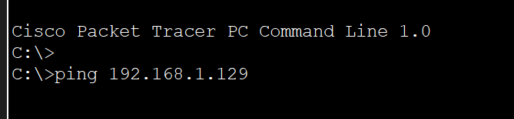
Figure 12:Pinging PC5
Using simulation mode, I analyzed how the entire ping process goes from PC1 to PC5. The Ping process prepares an ICMP Echo Request packet. The IPv4 header set the source IP to the interface in which it is sending it on, and destination IP to PC5’s IP, it realizes PC5 is outside its subnet, so it prepares to send it to the default gateway, by setting the ethernet frame destination mac address to that of the default gateway, but it runs into an issue, it can’t encapsulate it into an ethernet frame, because this is the first traffic going through the entire network that means the ARP process looks for the corresponding mac address to its default gateway, which is the next hop and it doesn’t have it. So, instead of the ICMP process sending an incomplete ICMP request frame, the ARP process prepares an ARP request frame for the default gateway and buffers the ICMP request packet.
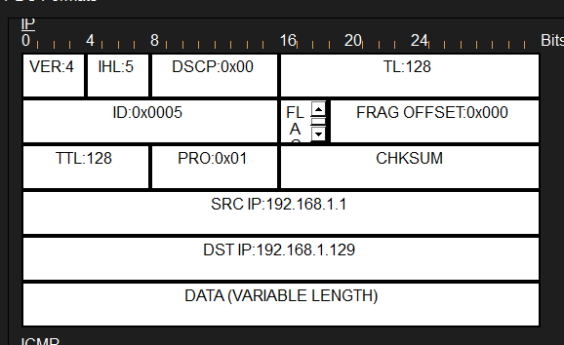
Figure 13: ICMP Echo Request Ipv4 header
The Arp frame is being prepared to be sent, with the broadcast address FFFF.FFFF.FFFF being set as the destination mac address in the ethernet header , and the default gateway being set as the destination IP in the ARP header.
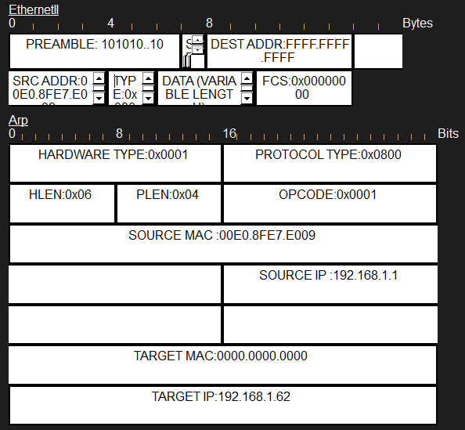
Figure 14: Ethernet and ARP header with broadcast address as target mac address
The ARP frame is sent via its Fast ethernet interface. Switch 1 receives the ARP frame. This is what SW1 does with the frame it first checks if the source mac address is in its mac address table, it won’t find it, because it hasn’t every received traffic before, so it would register the source mac address in its mac-address table. It then floods it out all the ports in the same broadcast domain as the port which it received it from, at the same the mac address needs to verify if the ARP frame is looking for its mac-address also, so it processes it with its ARP process. It looks into the ethernet frame and sees the ARP header, then checks the destination IP address if it matches its own, but since there is no configured IP address on a layer 2 switch, it drops the frame.
Since SW1 was going to flood it out of interfaces that are in the same broadcast domain as the interface in which it received the frame, this means it would flood it out of the access port F0/2 which goes to PC 2 and the trunk port F0/5 which goes the SW2. What was noted here, is the fact that the frame going to SW 2 would have the dot1q tag while the one going to PC 2 wouldn’t, this is because access ports are untagged ports, while trunk ports are tagged ports.
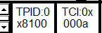
Figure 15: IEEE 801.1Q tag
Switch 2 receives the tagged ARP frame, and does the exact same thing SW1 did, the only difference is the interface in which it floods it out, it floods it out only its g0/1 interface, because that is the only port in the same broadcast domain as the interface it received it on. It sends it to g0/0 interface of the router, but the router receives it on the g0/0.10 sub-interface, because the frame is tagged with the as 000a as seen in figure 15, which means 10 in decimal, and because I ensured each sub-interface of the router could identify its own tag, that is why g0/0.10 received the frame.
The router has to process the frame because it is a broadcast frame, it de-encapsulates it from the ethernet dot1q header, it sees it is an ARP request, the ARP processes it, by checking if the destination Ip matches its own, and since the destination IP was the default gateway, which of course is the Router, ARP process verifies the frame is requesting for its mac address, it then prepares its own ARP reply frame, and adds its own mac address as its source mac address, while the destination mac-address becomes PC1s mac address. It then encapsulates it into an ethernet header and sends it out of its g0/0.10 interface.
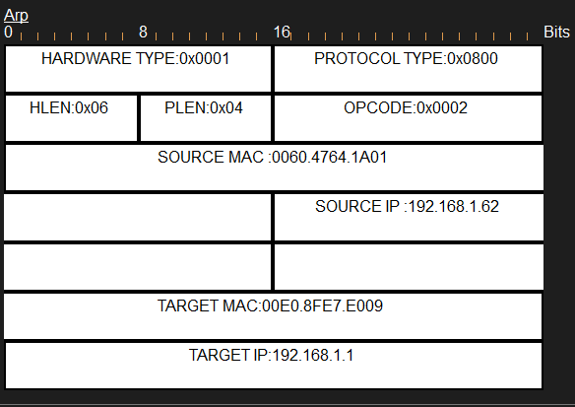
Figure 16: Arp header with the default gateway's mac address available
The ARP reply frame reaches SW2, but SW2 adds the source mac address on its mac address table, because the source mac address now, is the router’s mac address and it has never learnt that before. It doesn’t process it, because unlike a broadcast frame this is a known unicast frame, with its destination clearly written, so it forwards it to the interface where the destination is, which is the trunk interface, because it knows PC1s mac address (It learnt it from that ARP request). Also, the only reason why it was allowed through the trunk, is because the VLAN the frame is destined for is allowed in that trunk. SW1 does the same thing SW2 did, and forwards it to the destined interface, which PC1 is connected to.
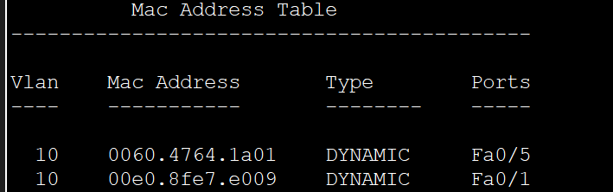
Figure 17: Mac address table showing mac addresses learnt by this switch
PC1 sees the destination mac address matches its own, so it de-encapsulates it, it sees it is an ARP reply, with mac address of the default gateway it requested for, it then adds it to it ARP table. It then brings out the ICMP packet which was waiting for an ARP reply that it buffered, and encapsulates it in a frame, since it has the required mac address then sends it out of its interface connected to the switch.
SW1 receives the ICMP frame, it already has the source mac address in its mac address table, so it looks for the destination mac address there, it sees its path is through the trunk port, so it tags it with the dot1q tag and forwards it. SW2 receives it, does the same thing and sends it to the router.
The router receives it on its g0/0.10 interface, it sees the mac address destination matches its own mac address, so it de-encapsulates it, sees the ipv4 header, it checks if the destination IP is in something called a CEF table, which is like a cache table, to access Ip routes faster than the routing table, since this is the first time it is receiving this traffic, it doesn’t see it there, so it then checks its routing table, and sees the route for this packet. The destination of this ICMP is 192.168.1.129 and this belongs to the 192.168.1.128/26 subnet I configured on the g0/0.12 interface as seen in figure 11. So, it prepares the ICMP echo request to be sent through the g0/0.12 interface, but it runs into the same problem, PC1 ran into initially, which is the fact it doesn’t have the mac address of the destination PC. Unlike PC1, the router doesn’t buffer the ICMP echo request, instead it drops it, and the first ICMP request has officially timed out. PC1 won’t send another request until the ARP process by the router to get PC5s mac address is successful.
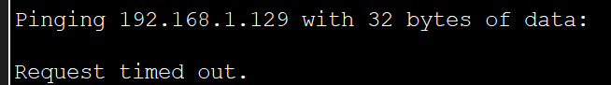
Figure 18: Frist request Failing
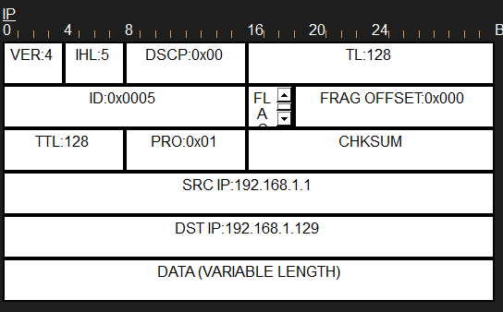
Figure 19: ICMP IPv4 header
Once ARP process for PC5’s mac address is complete. PC1 then sends the second ICMP request and once it gets to router this time, it sees the destination of IP on its CEF table, it then decrements the TTL (Time to Live) field by 1. Since it has the mac address of the destination in its adjacency table, which is part of the CEF table, it can then encapsulate it into a PDU frame tagged with 000c which means 12 in decimal in its dot1q field. It then sends it down to the connected g0/0.12 interface.
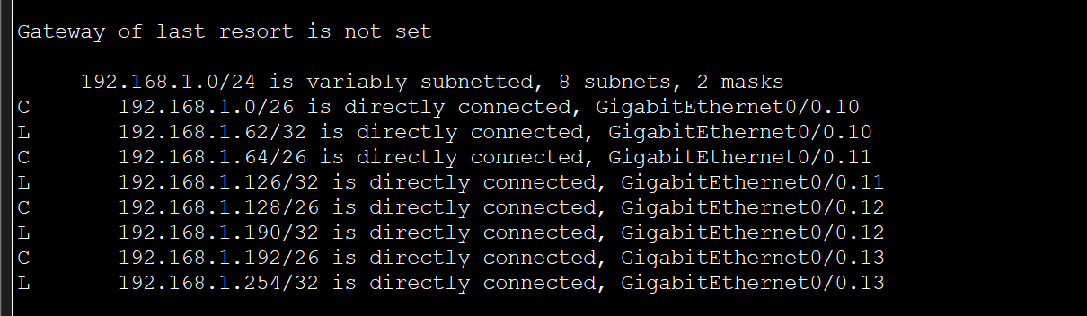
Figure 20: The routers routes
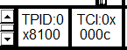
Figure 21: 802.1Q tag with VLAN 12 ID
The ICMP echo request then reaches PC5 via SW2. PC5, de-encapsulates it, it sees its an ICMP request, reads the header, and sees it is destined for itself, it then starts preparing its reply, it sets the source IP to be its own IP and destination to be PC1s, it then needs to de-encapsulate it with an ethernet frame, but it doesn’t have the next-hop mac address, which is the routers mac-address, so it buffers the ICMP reply and prepares an ARP frame, the entire ARP process, similar to the first ever one, repeats itself, and once PC5 gets the reply from the router, it then sends the ICMP echo reply to the default gateway to help it route it to PC1. The router finds the route in its CEF table, decrements the TTL field by 1, finds the mac address of PC1 in the adjacency table, tags it with appropriate dot1q tag, and sends it to PC1 via SW1 and SW2, once PC1 receives the reply it acknowledges it, the second ping is successful, then it prepares the third ICMP echo request. There are four ICMP echo request being sent by a PC, so it would get four replies. It is important to note that PC5 sends its reply with the TTL field of the IPv4 header set to 128, so what PC1 will receive is three replies in total with TTL of 127, because the router decremented it.
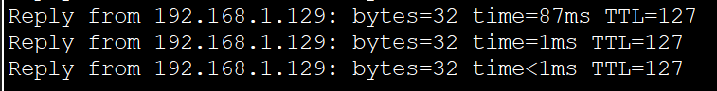
Figure 22: Three successful replies of ping message

TROUBLESHOOTING DONE
This are the issues I encountered while doing this project. When I was done with the configurations, I tried to ping to PC5 and all the pings failed. So, I had to begin troubleshooting, I then discovered two problems while troubleshooting, the first one didn’t really affect my pings, but the second one was the exact reason my ping failed. The first issue was the fact I didn’t configure the PCs in VLAN 13, but that couldn’t have affected my ping, because PC5, which is the PC I pinged was not in that VLAN, so no frame would reach that VLAN. The second issue, which was the main issue, was in the trunk path between SW1 and SW2, I mistakenly configured Switch 2’s trunk to allow VLAN 12 and VLAN 13, and that was the issue, because VLAN 12 and 13 would never need to pass through that trunk, only VLAN 10 and 11 will, so when the frame tagged with VLAN 10 or 11 was coming to SW2, its trunk won’t allow the frame to continue, ergo that is why all pings failed.

LESSONS LEARNT/MISCONCEPTIONS ADDRESSED
The following were either the lesson I learnt or misconceptions addressed, because I observed them in the simulation and walked it through with Claude AI.
- I used to wonder why an ARP frame always showed source and destination IP address, in the layer 2 block of the packet tracer, and not in the layer 3 block, because source and destination IP addresses are meant to be in IPv4 headers not ethernet frames. The misconception I had was the fact that the ARP (Address Resolution Protocol) was a layer 3 protocol like IPv4 and IPv6. So, I learnt that ARP is a layer 2 protocol that is why it was always in the layer 2 block with the ethernet header.
- I wondered how the ethernet header encapsulated the ARP since they are in the same layer of the TCP/IP model. I learnt that the layer 2 is divided into two parts, an upper and a lower layer, and ARP is in the upper layer, while ethernet is in the lower layer, so that is why the ARP could be encapsulated into an ethernet header.
- I never knew about the CEF (Cisco Express Forwarding), until I saw it on the packet tracer, apparently it is a high-speed layer 3 switching technology, which I saw the router use today, it uses two things. Forward Information, to quickly access routes, and adjacency table to know the mac-address of the next-hop, that is how the router knew the mac-address of the destination IP, by checking the adjacency table.
- This part is more like practical experience than, learning. I saw all those fields l learnt about ethernet header and IPv4 header in action, I saw field being implemented and updated.

CONCLUSION
I am really glad I did this project, and also the fact I documented it in such manner, this is my first ever documentation, and I would highly recommend this to anyone, learning networking, or anything at all. Take a time to do little projects on concepts that are clustered in your head, and do a documentation like this by yourself, it is a way of you re-teaching yourself. I would recommend Claude AI, because it was a good partner I had, in this project, I walked through misconceptions I had with it and even fact checked somethings it told me. I wouldn’t recommend you write the documentation with Claude, or an AI, because it defeats the whole point of the documentation, write it yourself, and you can use AI platforms, to proof-read.

